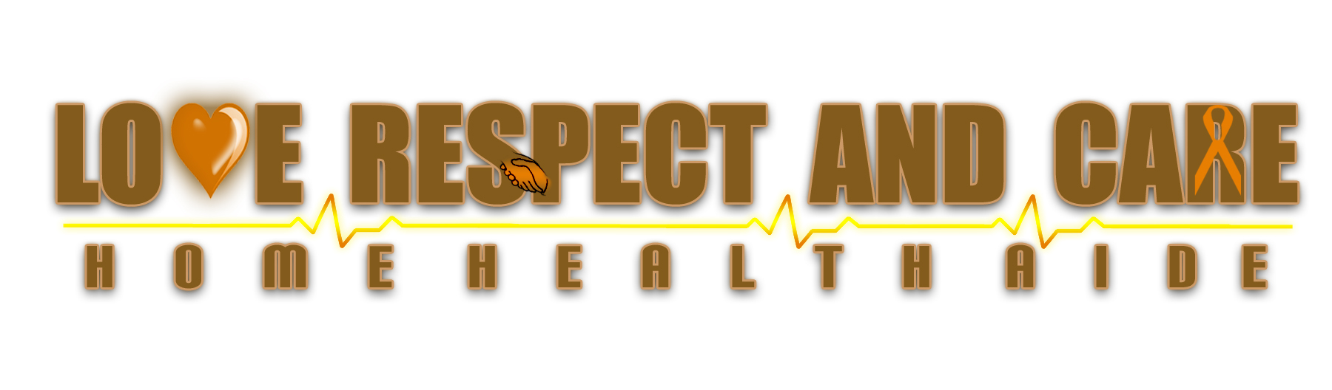

Direct Deposit Agreement Form:

Authorization Agreement
I hereby authorize Love Respect and Care Home Health Aide Agency/Registry LLC to initiate automatic deposits to my account at the financial institution named below. I also authorize Love Respect and Care Home Health Aide Agency/Registry LLC to make withdrawals from this account in the event that a credit entry is made in error.
Further, I agree not to hold Love Respect and Care Home Health Aide Agency/Registry LLC responsible for any delay or loss of funds due to incorrect or incomplete information supplied by me or by my financial institution or due to an error on the part of my financial institution in depositing funds to my account.
This agreement will remain in effect until Love Respect and Care Home Health Aide Agency/Registry LLC receives a written notice of cancellation from me or my financial institution, or until I submit a new direct deposit form to the Payroll Department.

Account Information
Name of Financial Institution:
Routing Number:
Account Number: |  | ☒ Checking | ☐ Savings

Signature
Authorized Signature (Primary): |  | Date:
Authorized Signature (Joint): |  | Date:

Please attach a voided check or deposit slip and return this form to the Payroll Department.

